**1.** **Write a program to design semantic and non - semantic tags with web page form layout to get this desired output ?**

<!DOCTYPE html>

<html lang="en">

<head>

<meta charset="UTF-8">

<meta name="viewport" content="width=device-width, initial-scale=1.0">

<title>Document Question 1</title>

</head>

<body>

<h1>Welcome to my website!</h1>

<p>This is the homepage of my website</p>

<h1>About Me</h1>

<p>My name is John Doe and I'm a web developer.</p>

<ol>

<li>HTML5</li>

<li>CSS3</li>

<li>JavaScript</li>

</ol>

<table>

<tr>

<td>Row 1, </td>

<td>Column 1 </td>

<td>Row 1, </td>

<td>Column 2</td>

</tr>

<tr>

<td>Row 2, </td>

<td>Column 1 </td>

<td>Row 2, </td>

<td>Column 2</td>

</tr>

</table>

<h1>Contact Me</h1>

<form>

<label for="name">Name: </label>

<input type="text" name="name" id="name">

<br>

<br>

<label for="email">Email: </label>

<input type="email" name="email" id="email">

<br>

<br>

<label for="message">Message:</label>

<textarea name="message" id="message" cols="20" rows="2" placeholder=""></textarea>

<br>

<br>

<input type="submit" value="Send">

</form>

<p>Write some content here</p>

<p>write Some more content here</p>

</body>

</html>

**Output :**

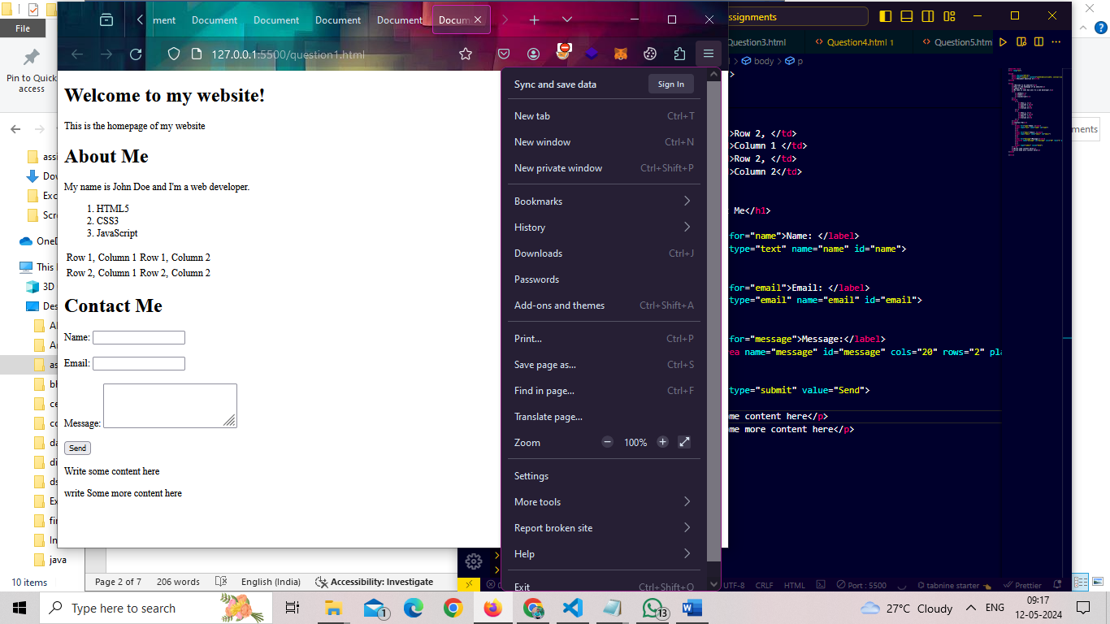

**2.Write a program to display the text formatting tags and meta tags in HTML as given below?**

<!DOCTYPE html>

<html lang="en">

<head>

<meta charset="UTF-8">

<meta name="viewport" content="width=device-width, initial-scale=1.0">

<title>Document Question 2</title>

</head>

<body>

<h1>Text Formatting Example</h1>

<p>This is <strong>important</strong> text</p>

<p>This is <em>emphasized</em> text</p>

<p>This is <u>underlined</u> text</p>

<p>This is <del>strikethrough</del> text</p>

<p>This is <sup>superscript</sup> and this is <sub>subscript</sub> text</p>

<p>This is <small>code</small> text</p>

<p>These tags will be used to make a <b>bold</b>, <i>italic</i>, and <u>underline</u> styles</p>

<pre>

This is preformatted text.

It preservers white space and line breaks.

</pre>

<blockquote cite="">

This is a block quote.

<br> It can be used to indicate a long quotation that is set off from the main text.

</blockquote>

<p>

<sup>Superscript text appears half a character above the normal line, and is sometimes rendered in a smaller <br>font</sup><sub>superscript text can be used for footnotes like www.</sub>

</p>

</body>

</html>

**Output :**

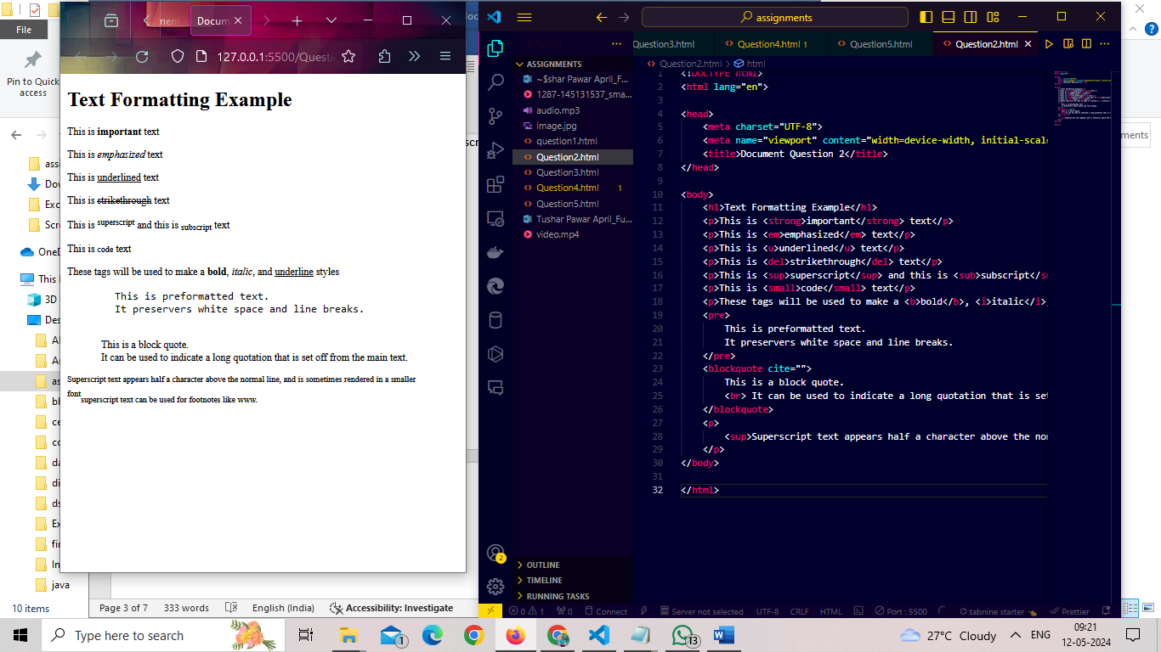

**3.Write a program to show all form input controls in HTML5 as given below ?**

<!DOCTYPE html>

<html lang="en">

<head>

<meta charset="UTF-8">

<meta name="viewport" content="width=device-width, initial-scale=1.0">

<title>Document</title>

</head>

<body>

<h1>Form Input Controls Example</h1>

<form action="">

<label for="name">Name: </label>

<input type="text" name="name" id="name" placeholder="Enter your name">

<label for="password">Password: </label>

<input type="password" name="password" id="password" placeholder="Enter your password">

<label for="email">Email: </label>

<input type="email" name="email" id="email" placeholder="Enter your email">

<label for="age">Age</label>

<input type="number" name="age" id="age" value="18">

<br>

<br>

<label for="rating">Rating: </label>

<input type="range" name="rating" id="rating">

<label for="dob">Date of Birth: </label>

<input type="date" name="dob" id="dob">

<label for="time">Time: </label>

<input type="time" name="time" id="time">

<label for="image">Image: </label>

<input type="image" src="./image.jpg" alt="flower" width="150px" height="50px">

<label for="week">Week: </label>

<input type="week" name="week" id="week">

<br>

<br>

<label for="month">Month: </label>

<input type="month" name="month" id="month">

<label for="datetime">Datetime-Local: </label>

<input type="datetime-local" name="datetime" id="datetime">

<label for="url">URL: </label>

<input type="url" name="url" id="url">

<label for="search">Search: </label>

<input type="search" name="search" id="search">

<p>Gender:</p>

<input type="radio" name="gender" id="male" value="Male">

<label for="male">Male</label>

<input type="radio" name="gender" id="female" value="Female">

<label for="female">Female</label>

<label for=""></label>

<p>Interests:</p>

<input type="checkbox" name="interest1" id="interest1" value="Reading">

<label for="interest1">Reading</label>

<input type="checkbox" name="interest2" id="interest2" value="Sports">

<label for="interest2">Sports</label>

<br>

<br>

<label for="country">Country: </label>

<select id="country">

<option value="India">India</option>

<option value="United States">United States</option>

</select>

<br>

<br>

<label for="message">Message: </label>

<textarea name="message" id="message" cols="30" rows="5" placeholder="Enter your message"></textarea>

<input type="submit" value="Submit">

</form>

</body>

</html>

**Output :**

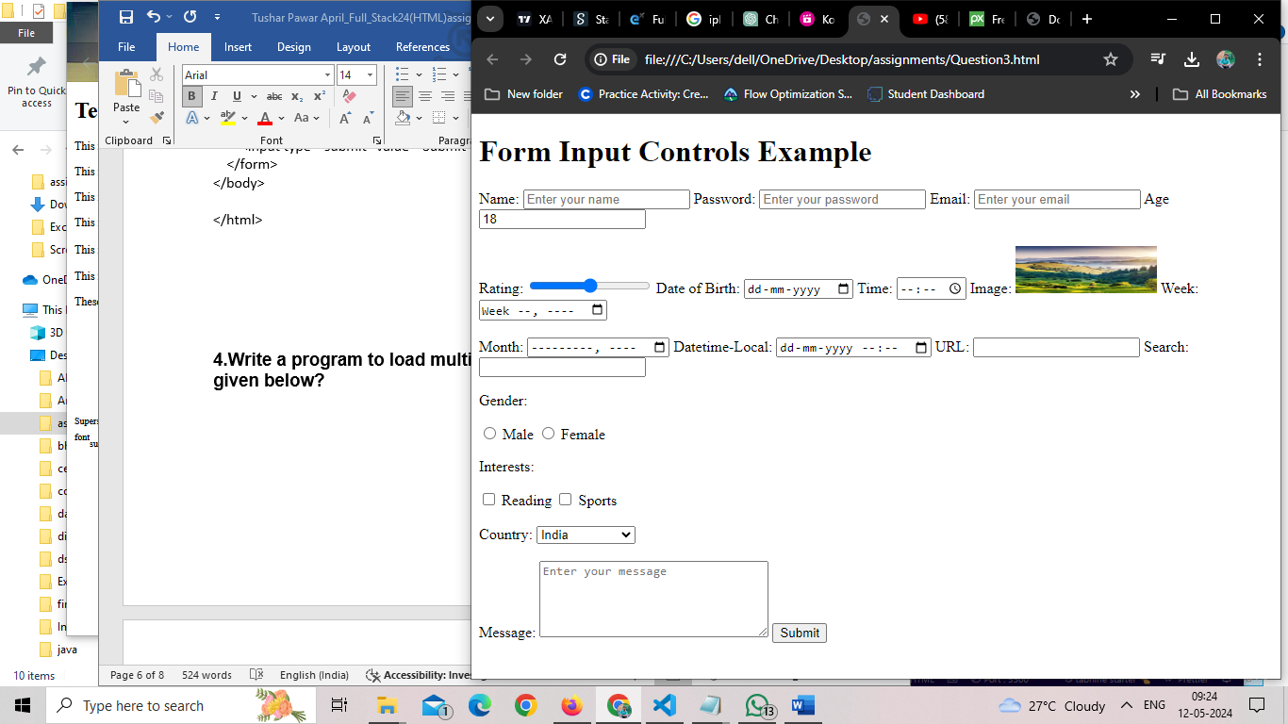

**4.Write a program to load multimedia content into a webpage like given below?**

<!DOCTYPE html>

<html lang="en">

<head>

<meta charset="UTF-8">

<meta name="viewport" content="width=device-width, initial-scale=1.0">

<title>Document</title>

</head>

<body>

<h1>Video</h1>

<video src="./video.mp4" controls></video>

<h1>IFrame</h1>

<iframe width="560" height="315" src="https://www.youtube.com/embed/8cUL_EkO7mU?si=KRurM1lN1PkZITb4" title="YouTube video player" frameborder="0" allow="accelerometer; autoplay; clipboard-write; encrypted-media; gyroscope; picture-in-picture; web-share"

referrerpolicy="strict-origin-when-cross-origin" allowfullscreen></iframe>

<h1>My Multimedia Website</h1>

<h2>Image</h2>

<img src="./image.jpg" alt="flower">

<h2>Audio</h2>

<audio controls>

<source src="./audio.mp3" type="audio/mp3">

</audio>

</body>

</html>

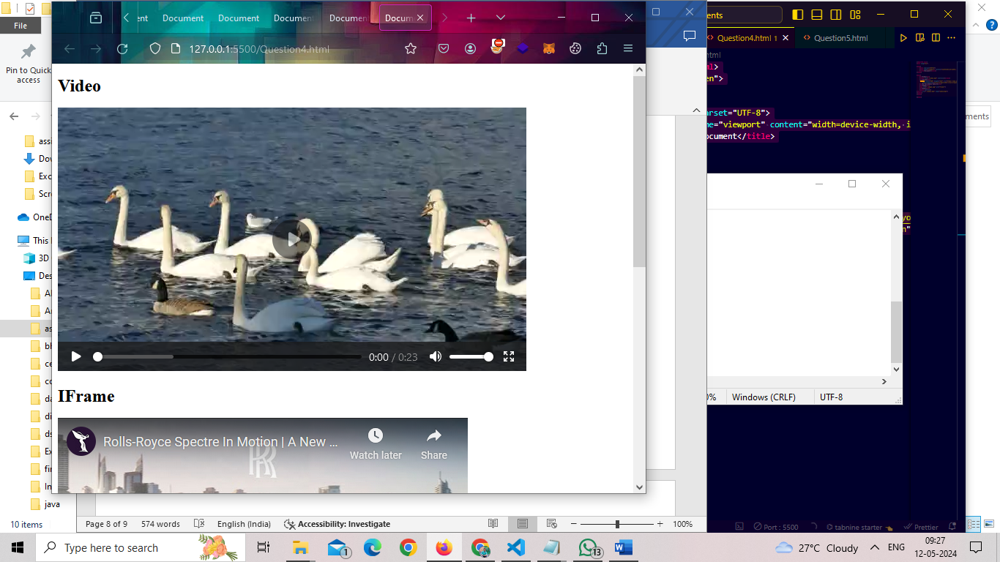

**Output :**

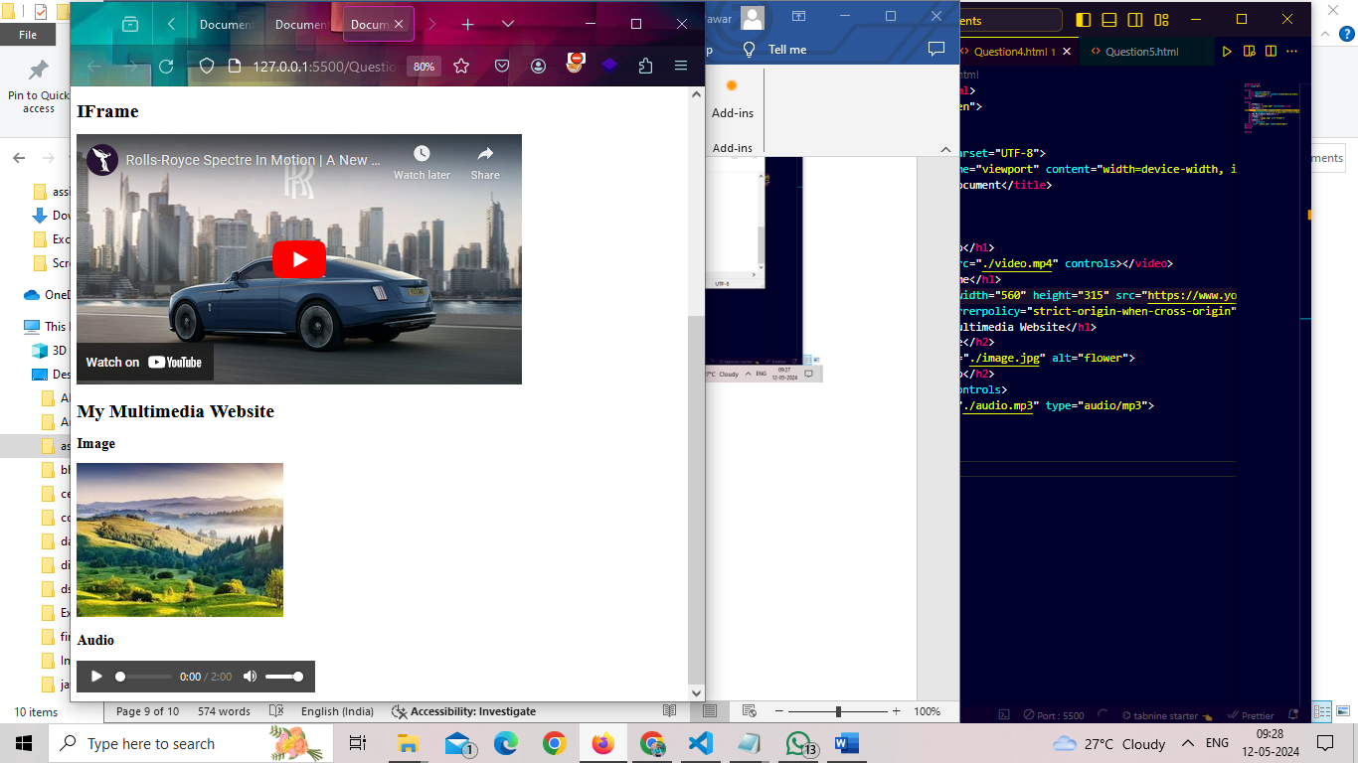

**5.Write a program to create ‘SVG’ inline and external like given below?**

<!DOCTYPE html>

<html lang="en">

<head>

<meta charset="UTF-8">

<meta name="viewport" content="width=device-width, initial-scale=1.0">

<title>Document</title>

</head>

<body>

<h1>SVG Inline Graphic Example</h1>

<svg width="300" height="130">

<rect width="100" height="100" x="10" y="10" fill="red" />

<circle r="40" cx="60" cy="60" fill="white" />

</svg>

<h1>External SVG Example</h1>

<svg height="200" width="300">

<image width="300" height="200" href="./image.jpg" />

</svg>

</body>

</html>

**Output :**

